Dataset Exploration Report (📄)

1. Introduction
- Dataset Source: COCO (Common Objects in Context)
- Purpose: Object detection in autonomous driving scenarios, aiming to identify and classify objects like pedestrians, vehicles, traffic signs, and obstacles in real-time.

2. Dataset Composition
- Number of Images: 29800
- Number of Objects (Bounding Boxes): 12
- Classes:

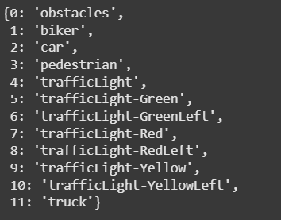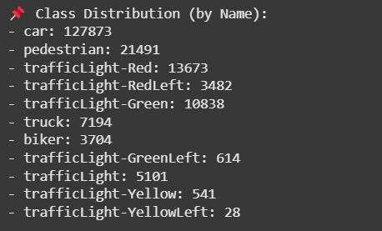

- Bounding Box Format: COCO format [x_min, y_min, width, height].

3. Class Distribution Analysis (📊)
- Histogram of Object Categories: A visualization showing the distribution of object categories to check for class imbalances.
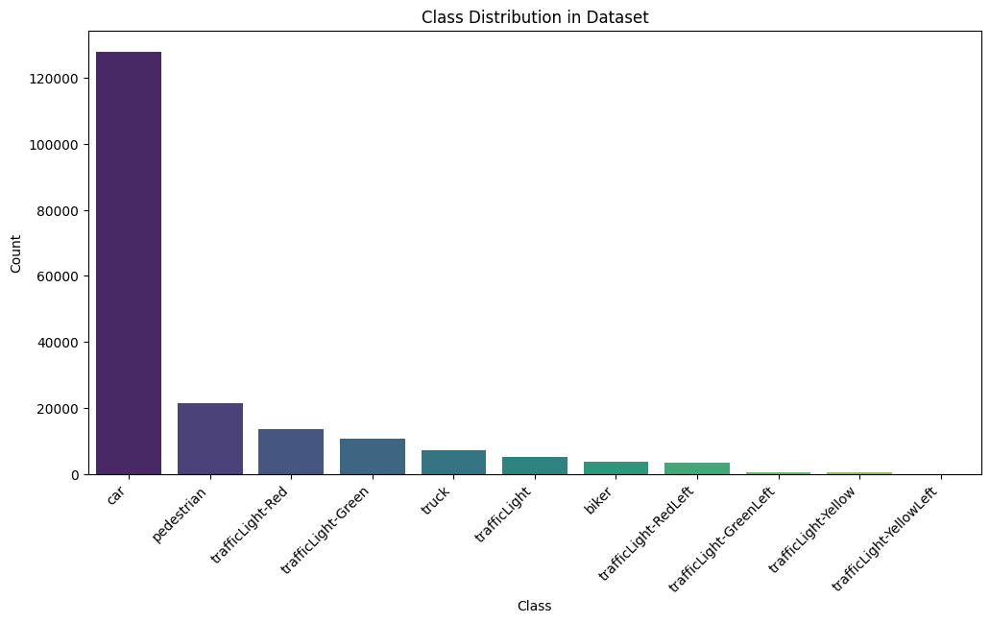
- Co-occurrence matrix:
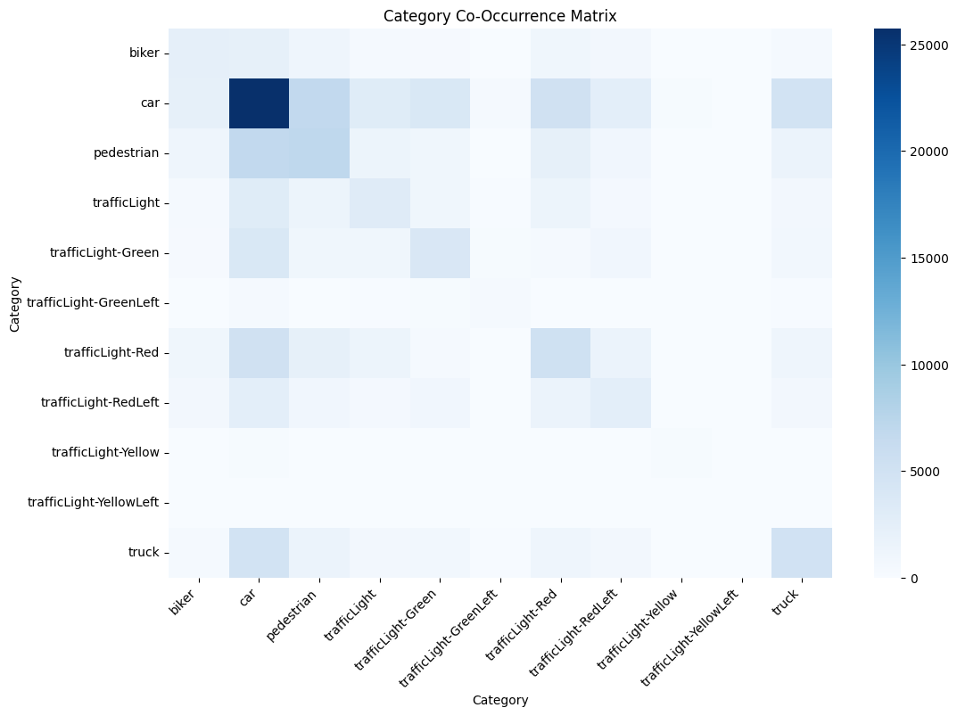

4. Image Quality & Metadata Analysis
- Resolution Distribution:
🔍 Image Resolution Stats:
📏 Min size: 512x512
📏 Max size: 512x512
📏 Avg size: 512x512
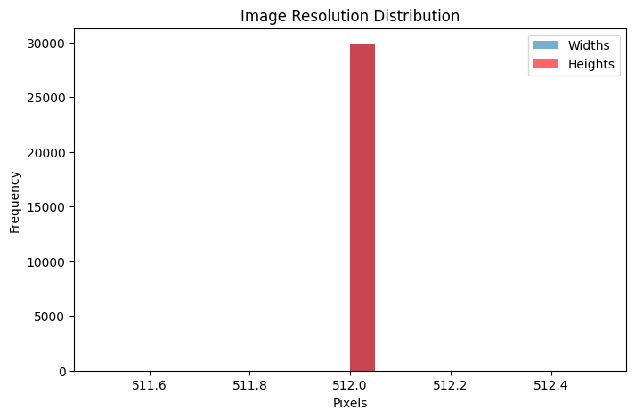
- Lighting & Weather Conditions:
⚠️ No weather metadata found in the dataset.
⚠️ No lighting metadata found in the dataset.

- Blur & Noise Analysis: Identification of images with low quality due to motion blur, poor lighting, or noise.

📉 Detected 0 blurry images out of 0.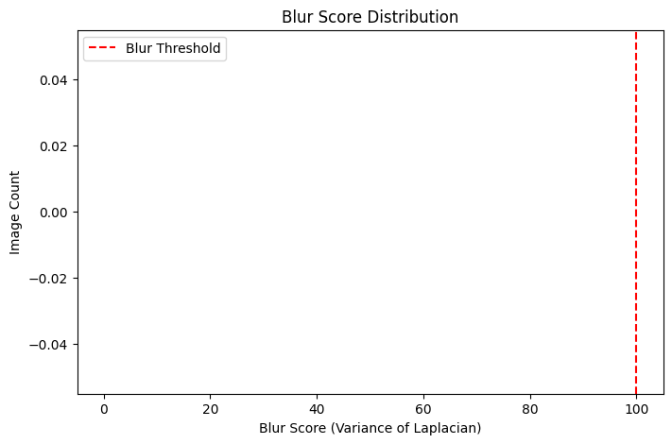

🔊 Detected 0 noisy images out of 0.
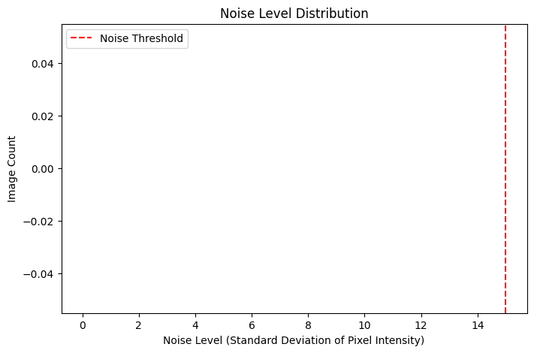

5. Bounding Box Validity Check
- Total Bounding Boxes: 194539
- Invalid Bounding Boxes: 243 (0.12%) (number and percentage of bounding boxes exceeding image dimensions or having negative coordinates).
- Bounding Box Size Distribution: Statistics on bounding box widths and heights.
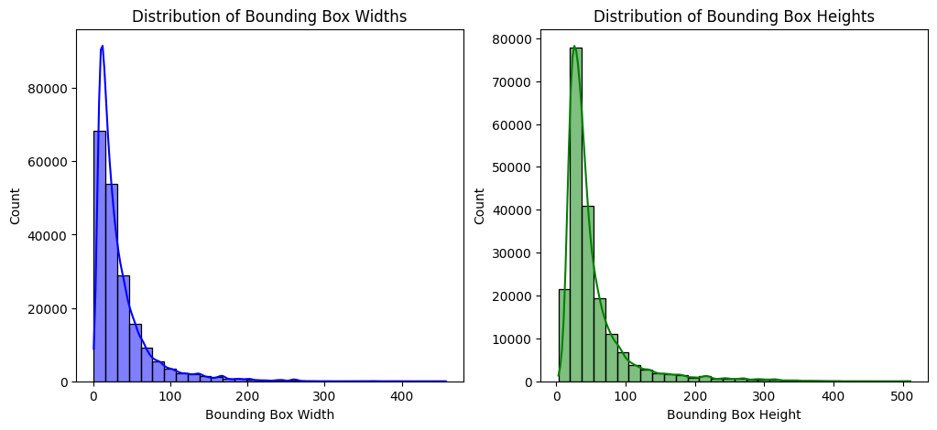
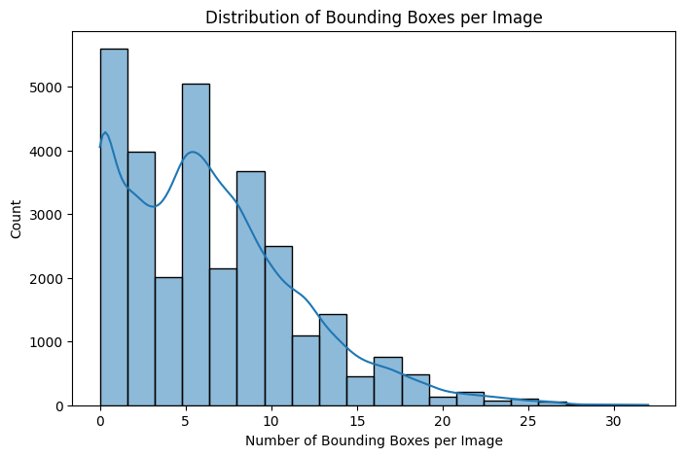
- 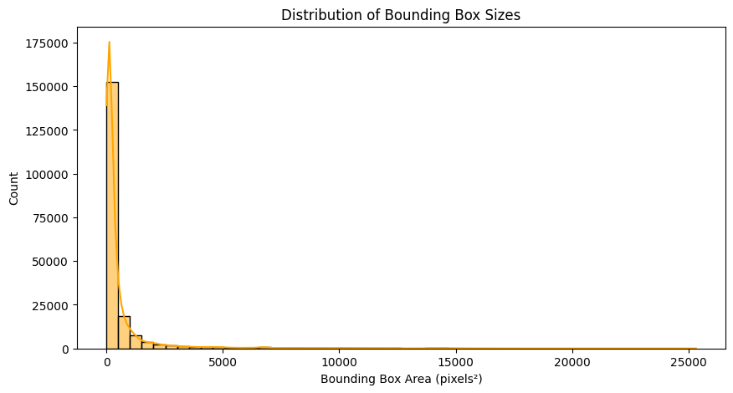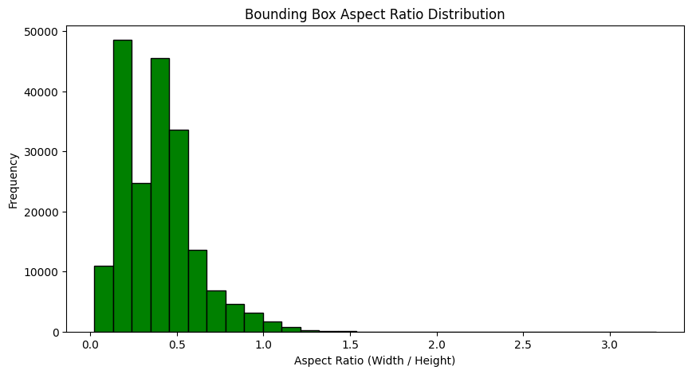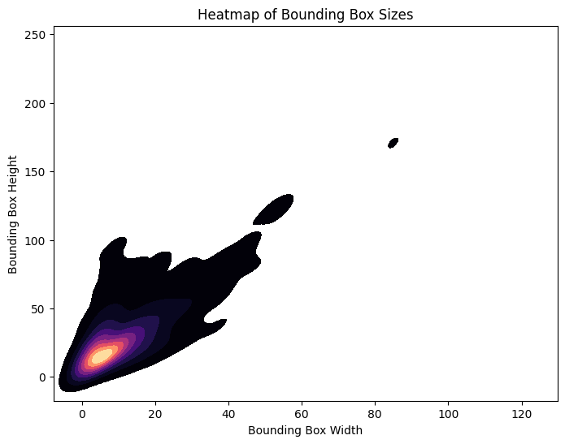
6. Data Preprocessing & Augmentation (Next Steps)
- Applying data augmentation techniques (random cropping, flipping, rotation).
- Adjusting bounding boxes after transformations.
- Preparing a final preprocessed dataset for training.

